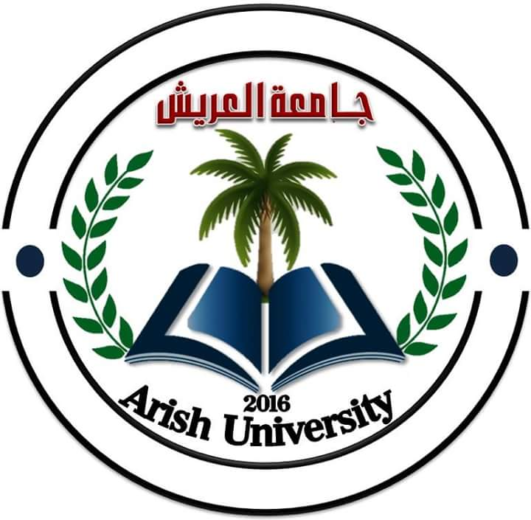
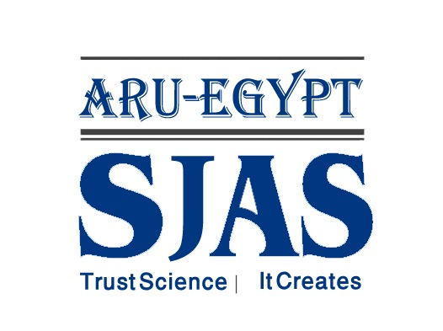

Available online at www.sinjas.journals.ekb.eg

SINAI Journal of Applied Sciences

Print ISSN 2314-6079
Online ISSN 2682-3527

EVALUATION THE SAFETY OF A POLYHERBAL FORMULATION OF Artemisia monosperma AND Mentha piperita IN MALE ALBINO RATS
Hagar E. Mohammed*
Dept. Zool., Fac. Sci., Arish Univ., North Sinai, Egypt.
ARTICLE INFO |  | ABSTRACT
Article history:  Received: 00/00/2024  Revised: 00/00/2024  Accepted: 00/00/2024 |  | Even though some polyherbal combinations have been used traditionally, there is limited scientific research on their safety and effectiveness. To address this gap, this study set out to explore the potential synergies and safety of a polyherbal formulation that contains A. monosperma and M. piperita. Specifically, the study examined the impact of this formulation on certain biochemical and hematological parameters in vivo. Materials and Methods: The study involved organizing the animals into eight groups, each comprising five animals. Group1, served as control group received distilled. Groups 2, 3, and 4, referred to as AL, AM, and AH received A. monosperma in doses of 1000, 3000, and 5000 mg/kg body, respectively. Group5, received 290 mg/kg of M. piperita extract. The remaining three groups, ALM, AMM, and AHM, received a mixture of A. monosperma and M. piperita in a polyherbal formulation (PF) at the same doses for 14 days, once daily. Results: The results showed that none of the treated animals died or showed signs of toxicity. Additionally, the polyherbal formulation did not cause any notable shifts in body weight or blood-related parameters, when compared to the control groups. Furthermore, the hepatic and renal functions remained unaffected using this formulation. Conclusion: Therefore, it can be concluded that the polyherbal formulation is harmless and non-poisonous, even at high doses of 5000 mg/kg, and has the potential to be employed as a diabetes remedy.
Keywords:
Artemisia monosperma, Mentha piperita, Polyherbal Formulation,
hematological and biochemical parameters, Scanning electron microscope.


Check for
updates

INTRODUCTION
The practice of herbalism involves utilizing plants and extracts for medicinal purposes, as a form of traditional medicine. For many years, people have relied on natural remedies to treat and prevent various ailments. In fact, these remedies have been more popular than modern medicine. The field of traditional medicine encompasses various forms of treatments, comprising vitamins, minerals, herbal remedies, nutritional supplements, and homeopathic remedies, which can interact with each other. 80% of people over the world were estimated by the world health organization uses this herbal medicine (WHO, 2005), either in individual or in combination (Parasuraman et al., 2014; Kaur et al., 2019), which considered being without side effects (Karakoca et al., 2013). In Ayurveda, combinations containing two herbs or more (polyherbal formulations), oils, or infusions (Che et al., 2013). Polyherbal formultions have therapeutic potential which is not found in drugs allopathic medicine (Parasuraman et al., 2014; Kaur et al., 2019). Nonetheless, the application of numerous amalgamations is based on trial and error as there is no empirical proof to support their advantages. For instance, it is uncertain whether the ratios of these mixtures are suitable, if the type of interaction they produce is favorable, or if their negative impacts are mitigated. Two such plants with a long history of use are Artemisia monosperma (commonly known as Aader as a local name) (Migahid and Hammouda, 1978) and Mentha piperita (peppermint). While these plants possess distinct characteristics, we are interested in exploring their potential synergy when used in combination.
Artemisia has a presence in Egypt through four wild species: Artemisia judaica L., Artemisia monosperma Delile, Artemisia scoparia Waldst, and Artemisia verlotiorum Lamotte. A fifth species, A. vulgaris L., is grown through cultivation. (Boulos, 2002). Artemisia monosperma (A. monosperma) is a sweet-smelling perennial shrub found in the deserts of Africa, China (Migahid and Hammouda, 1974; Bora and Sharma, 2011; Abad et al., 2012), and the Middle East. It can grow in desert plains and wadis, both inland and along the Mediterranean coast, and is often spotted near the northern Sinai coast (Badr et al., 2012). Traditional medicine employs A. monosperma to treat illnesses such as gastrointestinal problems (Dabe and Kefale, 2017), rheumatism, fever, hypertension, and parasitic worm infections (Hijazi and Salhab, 2010).
A. monosperma contains many beneficial compounds like coumarins (Hammoda et al., 2008), acetylenes (Saleh, 1985), sesquiterpenoids (Zaki et al., 2004), alkaloids (Zaki et al., 1984), flavonoids (Elgamal et al., 1997), triterpenoids (Lupeol and β-amyrin) (Elgamal et al., 1997; El Sayed et al., 2017), α-terpinolene, α-pinene, β-Pinene, shyobunone, and limonene (Khan et al., 2012).
Peppermint is a common name for Mentha piperita (M. piperita) and is used widely in folk medicine (Liu et al., 2006; Trevisan et al., 2017; Anwar et al., 2019). M. piperita is a hybrid plant that is cultivated by crossing two species, M. spicata and L M. aquatica. Peppermint is originally native to the Mediterranean region but has been widely distributed and utilized for its fragrance, flavoring, cosmetics, medicine, and pharmaceuticals (Balakrishnan, 2015).
Dried peppermint aerial parts were discovered in the Egyptian pyramids, indicating that this fragrant plant has been in use for more than a millennium. Peppermint has been shown to possess a variety of biological activities. Due to its cancer-fighting properties, potential to prevent cancer, effects on the kidneys, and ability to alleviate digestive issues such as anorexia, cramping, diarrhea, and nausea, this natural remedy has been widely used in traditional medicine for treating nervous system disorders and digestive complaints (Loolaie et al., 2017).
Interestingly, both A. monosperma and M. piperita share some documented medicinal uses, hinting at potential synergistic effects when combined.
Both A. monosperma and M. piperita possess a range of interesting medicinal properties. A. monosperma has been explored for its antimicrobial, anti-inflammatory (El Zalabani et al., 2017; El Sayed et al., 2017), antioxidant (Al- Soqeer, 2011; El Zalabani et al., 2017; Salih et al., 2023), and antidiabetic potential (Hijazi and Salhab, 2010; Badawy et al., 2022), while also showing promise in managing rheumatism (Hijazi and Salhab, 2010), spasms properties (Wagner and Wolff, 1977), and even cancer (Stavri et al., 2005). Similarly, M. piperita boasts antifungal, antimicrobial, antiviral, (Kamatou et al., 2013; Loolaie et al., 2017; Chumpitazi et al., 2018) and anti-inflammatory properties (Ghasemi-Pirbaluti et al., 2017; Chumpitazi et al., 2018; Anwar et al., 2019; Kehili et al., 2020), alongside potential applications in diabetes (Angel et al., 2013; Chandirasegaran et al., 2014; Abdellatief et al., 2017) and as an antioxidant (Schuhmacher et al., 2003). This shared focus on inflammation and potentially even blood sugar regulation suggests that combining these two herbs could lead to a synergistic effect, enhancing their overall therapeutic efficacy.
While the individual properties of A. monosperma and M. piperita offer a promising therapeutic arsenal, the potential benefits of their combined use remain largely unexplored. In our previous investigation into male reproductive health, we discovered that when given separately to rats, A. monosperma and M. piperita caused harm to the testicles and a decrease in sperm quality, which might result in infertility. Interestingly, the combination of both herbs seemed to counteract this damage (Mohammed et al., 2021). However, no published research has investigated the impact of this specific combination on hematological and biochemical parameters. This knowledge gap necessitates a safety evaluation of the A. monosperma and M. piperita combination before human use.
MATERIALS AND METHODS
Chemicals
Isoflurane was bought from Adwic-El Nasr Pharmaceutical Co. (Cairo, Egypt). The biochemical assays were performed using assay kits that were products of Bio-diagnostic Egypt- Spinreact, Girona, Spain- BIOMED Diagnostics, Oberschleißheim, Germany- Diamond Diagnostics, Germany- SPECTRUM, Egypt. The chemicals and reagents employed were sourced from standard commercial suppliers and met the requirements for analytical grade.
Plant Material and Authentication
During December 2022, A. monosperma and M. piperita were harvested from the northern Sinai desert in Arish, Egypt. Dr. Nashwa A. M. Mostafa, a taxonomist, confirmed the plants' identity, and voucher specimens were kept in the Herbarium of the Faculty of Science, Arish University, North Sinai, Egypt. Accession numbers A3448 and L4532 were allocated to the specimens.
Aqueous Extracts Preparation
The aerial parts of A. monosperma were dried in the shade, then finely ground using an electric blender. A hot water extract was created using the process outlined by Abdel-Salam et al. (2009). This involved adding 50 g of Artemisia powder to a flask containing 1000 ml of distilled water, boiling for 15 minutes, and filtering the mixture twice with Whatman No.2 filter paper. The final concentration of the extract was 5% total solid and it was stored in a sterile dark bottle in a cool place (4°C) until needed.
M. piperita leaves were washed, dried, and had their roots removed before being placed in tap water. The extract was made using a concentration of 100 mg/ml, which is equivalent to the daily intake of an adult man (Barbalho et al., 2011). The resulting water extract was filtered into a dark bottle and stored at -80C. Prior research has demonstrated that a dosage of 290 mg/kg b.wt. over 14 days is safe for all organs (Johari et al., 2015). When ready for use, the extract was thawed and left at room temperature for two hours.
Combining the Extracts
The preparation of the polyherbal formulation proceeded following the determination of the optimal dosages through previous studies. Under aseptic conditions, precisely measured volumes of each extract, corresponding to the chosen doses, were combined within a sterilized container. Gentle agitation ensured homogeneous mixing to achieve a uniform blend. The final formulation is stored in a dark, airtight container in a cool environment (4°C).
Ethical Considerations
The Animal Care and Ethics Committee (ACEC) of Arish University in North Sinai, Egypt, gave us ethical clearance for our work (No.). We took great care to lessen the pain and suffering of the research animals in accordance with ACEC recommendations.
Animals
We bought adult male albino rats from Cairo-based Egyptian vaccination producer VACERA. The experiments started after they had a week to become used to their new environment. The rats were kept in an animal facility that had good ventilation, a 12-hour light and dark cycle, and a temperature control of 22–24°C. The rats were given adlib tum and fed pellets of rat chow. The investigation was carried out at Arish University's Faculty of Science's Animal House Lab. All animal studies were conducted in accordance with the rules set forth by the Institutional Animals Ethics Committee of the Faculty of Science, Arish University, El-Arish, Egypt, and the National Institutes of Health's (NIH Publication, 1985) guidelines for the care and use of laboratory animals.
Experimental Design
Consisting of male albino rats that were in good health, aged between 2-3 months, and weighing between 260-275 grams. After that, the rats were split up into eight groups, each with five rats. Group 1 (control) got distilled water whereas Groups 2, 3, and 4 (AL, AM, and AH) received an aqueous extract of A. monosperma at doses of 1000, 3000, and 5000 mg/kg, respectively, Group 5: was given 290 mg/kg of M. piperita aqueous extract. The extract of the polyherbal formulation of A. monosperma and M. piperita, given at the identical dosages of the two plants previously mentioned, was given to the remaining three groups (6), (7), and 8 (ALM, AMM, and AHM). For fourteen days, each treatment was given orally once a day. The A. monosperma doses were selected based on the findings of El Sayed et al. (2017), a study that reported the LD50 of the species to be as high as 6.1g/kg b.wt. The animals were observed during the treatment period for any abnormalities, and at the end of the trial, their body weights were noted.
Blood Sample and Organs Collection
At the end of treatment, the animals were fasted overnight but had access to water. The rats were given isoflurane anesthesia and killed with a sterilized surgical blade to ensure that the procedure was humane. For morphological and hematological examination, we took blood samples using a tube containing the anticoagulant ethylene diamine tetra acetic acid (EDTA), and for clotting, we used a different set of plain sample vials. To extract serum, the clotted blood samples were centrifuged for 20 minutes at 3,000 rpm. Before they were ready for analysis, the serum samples were stored in a freezer at -80 °C.
Determination of Body and Relative Organs Weight
During the 14-day experiment, the gain of body weight (BWG) was determined by recording the initial and final body weight of each group, using the formula provided by Chapman et al. (1959).
BWG%= (Final body weight – Initial body weight)/ Initial body weight×100
The selected organs liver, kidneys, heart, brain, stomach, and spleen were removed immediately after animal dissection. The organs have been cleaned in saline of any accessory tissues. The absolute organs weight was divided by the final body weight (×100) to calculate the relative organs weight.
Hematological Parameters Determination
Freshly EDTA blood samples were performed on an ABX Pentra (Horiba, Montpellier, France) following the manufacturer's instructions. The following analyses were carried out: total RBCs, hemoglobin (HB) concentration, mean cell hemoglobin (MCH), haematocrit (Hct), mean cell hemoglobin concentration (MCHC), mean cell volume (MCV), Red blood cell distribution width (RDW-CV), total white blood cells (WBCs), LYM, and platelet (PLT) were analyzed.
Morphological Examination
For morphological examination, EDTA blood samples were collected for Scanning electron microscope (SEM) and Light microscope (LM) analysis.
Light microscope (LM) analysis
EDTA blood samples were smeared on slides and allowed to air dry. The blood smear specimens were fixed with absolute methanol for 10 minutes. Once air-dried, the specimens were stained using Giemsa stain solution (Sigma Aldrich Company, USA) for 20 minutes, as per the manufacturer's recommendations. The cells were then observed under an optical microscope (100x, Olympus) and photos were taken using an Olympus E 420 camera. The RBCs were classified as normocytes, target cells, echinocytes, Rouleaux, and acanthocytes (Jones, 2009).
Scanning electron microscope (SEM) analysis blood sample preparation for SEM
Upon arrival at the laboratory, EDTA blood samples were promptly processed at room temperature for microscopic investigation. The blood sample was obtained, and after 10 minutes of centrifugation at 2,000 rpm, the leukocyte layer was separated and placed in a 1.5 ml Eppendorf tube. To fix the leukocytes till additional examination, glutaraldehyde from Adwic-El Nasr Pharmaceutical Co. (Cairo, Egypt) was applied. The sample was then centrifuged one more for one minute at 6,000 rpm, and only the precipitate was extracted by decanting the mixture. The precipitate was combined with 1X phosphate buffered saline solution (pH = 7.4) obtained from Adwic-El Nasr Pharmaceutical Co. (Cairo, Egypt), left for five minutes, and then stirred again. This process was iterated three times. Subsequently, 60% alcohol was introduced, and the resulting precipitate was allowed to settle for 10 minutes. Afterward, the sample underwent centrifugation at 6,000 rpm for 1 minute. This sequence was replicated using alcohol concentrations of 70%, 80%, 90%, 96%, and finally 100%. Following this, 100% pure acetone was applied and fixed within a dark-bottomed aluminum cylinder, ready for coating with gold particles using the Desk II Denton vacuum equipment in Lawrence, Kansas. The sample was then examined utilizing a Zeiss Ultra plus Field Emission Gun Scanning Electron Microscope (SEM) from Carl Zeiss Microscopy, Europe, Germany, as described by Fischer et al. (2012), to capture micrographs of the erythrocytes.
Biochemistry Parameters Analysis

Liver functions determination
Serum was analyzed for the determination of levels of glucose using Kits from Bio-diagnostic Egypt (Catalogue #: GL 13 20). Additionally, commercial kits from Spinreact in Girona, Spain were used to assess the activities of serum aminotransferase alanine (ALT) and aspartate (AST) (Kodikonda and Naik, 2017). The content of total protein was determined by commercial kit (REF: TP116150; BIOMED Diagnostics, Oberschleißheim, Germany) (Weichselbaum, 1946). Direct and total bilirubin levels were assessed with a kit from Diamond Diagnostics, Germany (REF: BIL099100) (Doumas et al., 1973). The level of albumin was assessed by the colorimetric modified bromocresol green method by using commercial kit (ALB210002, SPECTRUM, Egypt) (Bartholomev and Delany, 1966).

Kidney functions determination
For determining the levels of urea and creatinine, commercially available testing kits were employed (URE118200, CRE106240; BIOMED Diagnostics, Oberschleißheim, Germany) (Kodikonda and Naik, 2017). Meanwhile, the uric acid testing kit used was from SPECTRUM, Egypt (REF: 323001) (Fossati and Prencipe, 1982).
Determination of lipid profile
Commercial kits (TC; CAT. No.: CH 1220, TG; CAT. No.: TR 2030, HDL-C; CAT. No.: CH 1230, respectively; Biodiagnostic, Dikka, Egypt) were utilized to measure the levels of triglyceride (TG), Total cholesterol (TC), and high-density lipoprotein cholesterol (HDL-C), as outlined in the study by Kodikonda and Naik (2017), for the evaluation of the lipid profile.
Determination of minerals
The levels of calcium (Farrell et al., 1984), potassium (Berry et al., 1989), and sodium (Henry et al., 1974) in the serum were assessed using commercial kits provided by SPINREACT, Obour city industrial area.
All parameters were determined by using suitable kits and according to the manufacturer's instructions.
Statistics of Analysis
Statistical analyses were conducted using Graphpad Prism 8.0.1 software (San Diego, CA, USA). Results are expressed as mean ± SEM of n = 5. One-way analysis of variance (ANOVA) was performed, followed by Tukey’s multiple comparisons tests, to compare the means of all groups to each other. Statistical significance was considered at p ≤ 0.05. Symbols *P < 0.05, **P < 0.01, ***P < 0.001, and ****P < 0.0001 were used to denote statistical differences compared to the control group, while #P < 0.05, ##P < 0.01, ###P < 0.001, and ####P < 0.0001 were used for statistical differences compared to the mint group.
RESULTS
Effect of PF Administration on Body Weight Gain and Relative Organ Weight in Rats at 14 Days of $treatment
The impact of administering polyherbal formulation (PF) on body weight gain and relative organ weight in rats was recorded in Tables 1 and 2. The rats showed no toxic reactions to the herbs, whether used alone or together. After comparison to the control group, no significant differences were found (p≤0.05) in the weight gain or organ weight of in all treated rats.
Effect of PF Administration on Red Blood Cell Morphology in Rats at 14 Days of Treatment
To assess the impact of a polyherbal extract on the shape of RBCs, LM and SEM microscopy were used (Fig. 1A and 1B; Fig. 2). The LM analysis revealed that the RBCs of the control group rats were round, biconcave discs with a central pallor, which is a typical RBC shape known as a discocyte in SEM analysis or a normocyte in LM analysis. When stained with Geimsa’s solution, RBCs appear pink because the hemoglobin content of the RBC picks up eosin, the acidophilic component of the dye. In contrast, the groups that were treated with A. monosperma extracts showed significant morphological changes such as echinocytes, acanthocyte, target cell, and Rouleaux. Moreover, the SEM results of ultrastructural analysis revealed abnormal morphology, including acanthocyte and echinocytes.
Effect of PF Administration on Hematological Parameters in Rats at 14 Days of Treatment
During a 14-day study, the oral administration of aqueous extract of A. monosperma or M. piperita or polyherbal extract at different doses did not result in any significant alterations in hematological parameters, except for platelet count which

Table1. Effect of PF administration on body weight gain in rats at 14 days of treatment
Parameters | Groups
Parameters | Control | AL | AM | AH | M | ALM | AMM | AHM
Initial body  weight (g) | 266±11.2 | 272±17.1 | 259±15.42 | 276±22.8 | 275±12.2 | 273±13.2 | 268±22.6 | 270±13.8
Final body  weight (g) | 277±15.4 | 265±17.7 | 296±25.1 | 316±65.1 | 300±33.1 | 292±21.2 | 285±55.2 | 271±24.1
body weight gain. BWG (%) | 6.17 ± 0.54 | 4.06±0.54 | 8.84±1.28 | 7.12±1.05 | 8.58±0.70 | 10.19±0.47 | 8.93±0.75 | 8.28±1.27
The values were expressed as mean ± SEM. Distinguishing symbols on the bars (*, #) indicate significant differences at p < 0.05 (* versus control group, # versus mint group), determined by a one-way ANOVA test followed by Tukey's test.

Table 2. Effect of PF administration on relative organ weight in rats at 14 days of treatment
Parameters | Groups
Parameters | Control | AL | AM | AH | M | ALM | AMM | AHM
Relative liver  weight (%) | 2.58± 0.11 | 2.49± 0.06 | 2.44± 0.15 | 2.39± 0.04 | 2.12± 0.06 | 2.33± 0.05 | 2.68± 0. 38 | 2.52± 0.21
Relative Heart  weight (%) | 0.35±0.02 | 0.42±0.01 | 0.32±0.04 | 0.35±0.15 | 0.35±0.03 | 0.33±0.02 | 0.46±0.07 | 0.35±0.02
Relative L.  Kidney weight (%) | 0.33±0.02 | 0.36±0.02 | 0.32±0.02 | 0.57±0.17 | 0.3±0.009 | 0.33±0.02 | 0.35±0.04 | 0.3±0.01
Relative R.  Kidney weight (%) | 0.34±0.02 | 0.37±0.02 | 0.29±0.03 | 0.36±0.01 | 0.3±0.01 | 0.32±0.01 | 0.33±0.06 | 0.34±0.01
Relative Lung weight (%) | 0.93±0.12 | 0.62±0.03 | 0.56±0.05 | 0.71±0.13 | 0.58±0.03 | 0.56±0.03 | 0.59±0.07 | 0.63±0.08
Relative Spleen weight (%) | 0.28±0.02 | 0.24±0.02 | 0.24±0.01 | 0.26±0.01 | 0.26±0.006 | 0.23±0.01 | 0.29±0.02 | 0.26±0.03
Relative Brain weight (%) | 0.55±0.03 | 0.53±0.04 | 0.56±0.05 | 0.67±0.08 | 0.56±0.01 | 0.57±0.03 | 0.54±0.03 | 0.62±0.05
Relative Stomach weight (%) | 0.54±0.04 | 0.58±0.06 | 0.5±0.03 | 0.53±0.05 | 0.52±0.02 | 0.58±0.05 | 0.54±0.04 | 0.55±0.03
The values were expressed as mean ± SEM. Distinguishing symbols on the bars (*, #) indicate significant differences at p < 0.05 (* versus control group, # versus mint group), determined by a one-way ANOVA test followed by Tukey's test.

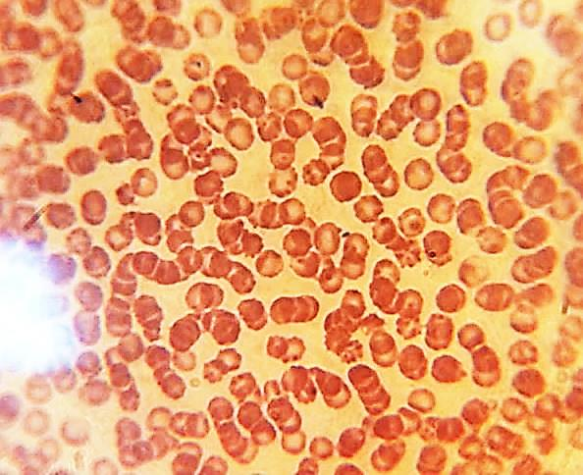
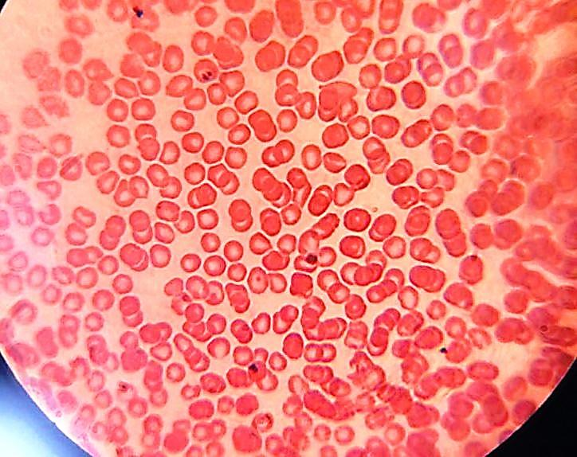
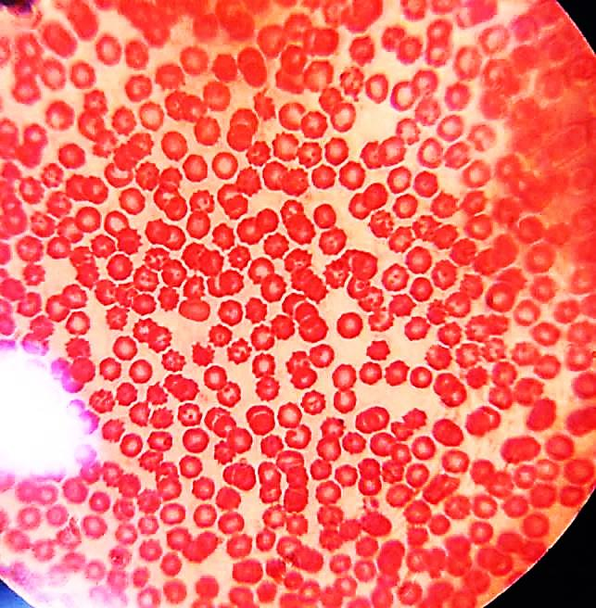
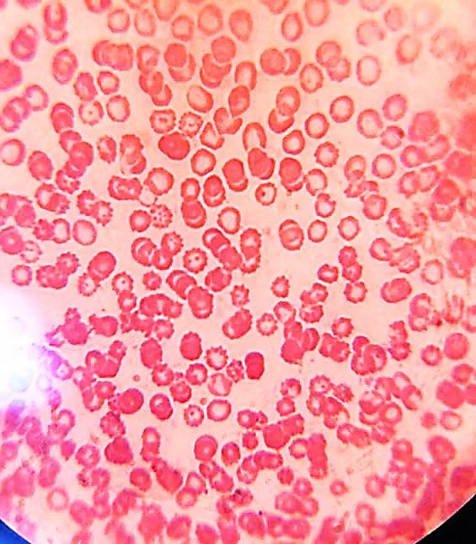
M
C
AH
AL

Fig. 1A. Light microscopy smears and optical micrographs at 100 × of rats, showing the normal (yellow arrow) and abnormal forms of RBCs. Echinocytes (green arrow), Acanthocytes (black arrows), target cells (blue arrows) and Rouleaux (purple arrow)
.

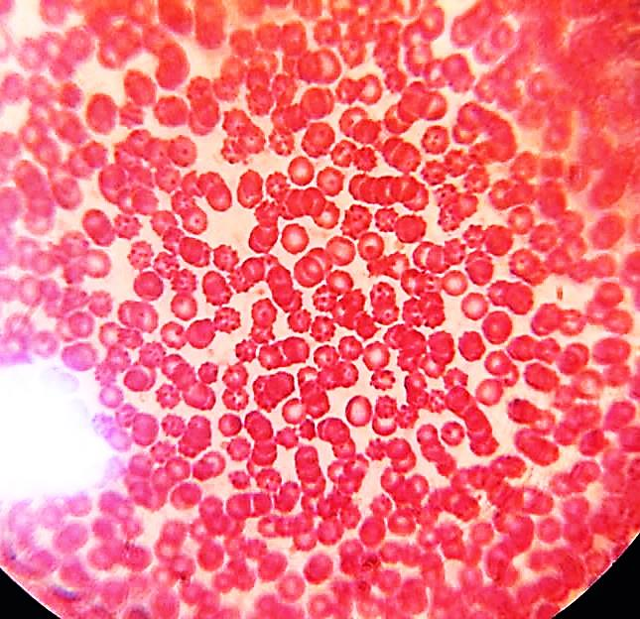
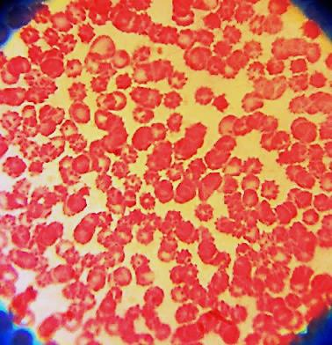
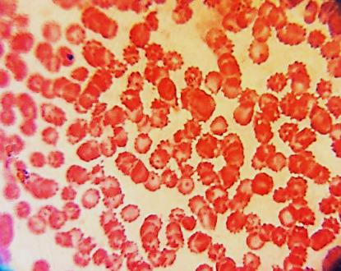
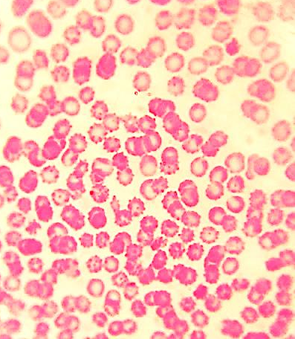
AHM
AMM
AM
ALM

Fig. 1B. Light microscopy smears and optical micrographs at 100 × of rats, showing abnormal forms of RBCs. Echinocytes (green arrow), Acanthocytes (black arrows), target cells (blue arrows) and Rouleaux (purple arrow)
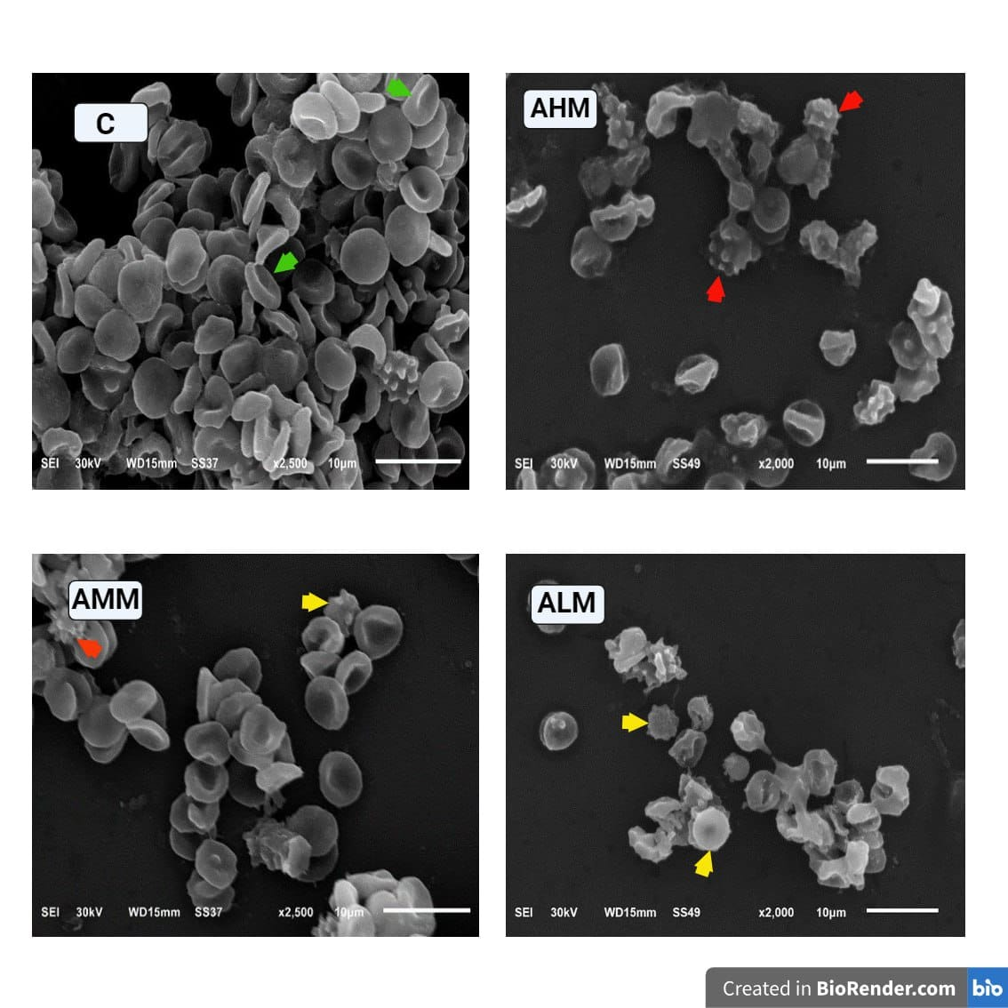
Fig. 2. SEM images of normal and abnormal RBCs in rats: (c) Normal erythrocyte morphology (green arrowhead), echinocytes (yellow arrowhead), and acanthocytes (red arrowhead arrow)

Table 3. Effect of PF administration on hematological parameters in rats at 14 days of treatment
Parameters | Groups
Parameters | Control | AL | AM | AH | M | ALM | AMM | AHM
RBCs  (×10⁶ /mm³) | 8.08 ± 0.16 | 7.44 ± 0.2 | 7.50 ± 0.19 | 8.04 ± 0.16 | 8.11 ± 0.15 | 8.18 ± 0.2 | 7.94 ± 0.14 | 7.55 ± 0.21
HB g/dL | 13.67 ± 0.31 | 12.73 ± 0.33 | 13.08 ± 0.12 | 13.22 ± 0.26 | 13.3 ± 0.23 | 13.95 ± 0.33 | 13.33 ± 0.21 | 12.67 ± 0.31
HCT % | 42.9 ± 0.85 | 40.65 ± 1.22 | 40.92 ± 0.74 | 42.9 ± 0.85 | 43.72 ± 0.58 | 45.72 ± 1.37 | 43.28 ± 0.64 | 40.55 ± 1.1
MCV fL | 53.27 ± 2.26 | 54.97 ± 0.96 | 54.68 ± 0.49 | 53.38 ± 0.55 | 53.96 ± 0.85 | 55.9 ± 0.81 | 54.55 ± 1.09 | 53.75 ± 0.34
MCH pg | 16.83 ± 0.35 | 17.13 ± 0.4 | 17.47 ± 0.28 | 16.45 ± 0.27 | 16.42 ± 0.4 | 17.08 ± 0.28 | 16.8 ± 0.42 | 16.82 ± 0.13
MCHC g/dL | 30.7 ± 0.1 | 31.38 ± 0.37 | 31.93 ± 0.27 | 30.83 ± 0.27 | 30.42 ± 0.25 | 30.57 ± 0.27 | 30.8 ± 0.19 | 31.23 ± 0.28
WBCs (× 10³/mm³) | 8.13 ± 0.57 | 7.68 ± 1.17 | 9.0 ± 0.63 | 8.22 ± 0.86 | 7.52 ± 0.83 | 10.3 ± 1.54 | 9.17 ± 1.41 | 8.68 ± 1.12
LYM (%) | 5.95 ± 0.33 | 5.5 ± 0.77 | 6.32 ± 0.48 | 5.78 ± 0.52 | 5.78 ± 0.89 | 7.55 ± 1.62 | 6.88 ± 1.2 | 7.1 ± 1.14
PLT (x10³/mm³) | 1084 ± 18.68 | 1111 ± 53 | 1375 ± 41.0* | 1121 ± 100.45 | 1012 ± 24.1 | 1066 ± 20.33 | 1074.67±72.55 | 1166 ± 43.66
The values were expressed as mean ± SEM. Distinguishing symbols on the bars (*, #) indicate significant differences at p < 0.05 (* versus control group, # versus mint group), determined by a one-way ANOVA test followed by Tukey's test.

was found to be significantly increased at 3000 mg/kg of A. monosperma (p<0.05). In contrast, the animals treated with polyherbal extract at all doses did not exhibit any change in platelet count when compared to the control and mint groups.
Effect of PF Administration on Biochemical Parameters in rats at 14 Days of Treatment
The results indicated that rats supplemented with A. monosperma or M. piperita administered either alone or in combination had lower serum glucose concentrations. Meanwhile, the data presented in Table 4 indicate that neither the administration of A. monosperma nor M. piperita, either alone or in combination, resulted in significant changes in hepatic transaminases AST and ALT activities, as well as T. BIL and CRA levels. However, the administration of the polyherbal extract at a high dose led to a substantial increase in ALB levels (p < 0.001) and T. protein levels (p < 0.0001) compared to the control and mint groups. Moreover, the level of D.BIL was elevated in the AH and ALM groups (p < 0.0001). Additionally, a significant change in urea levels (p < 0.0001) and uric acid levels (p < 0.05) in a dose-related manner were observed in the treated groups compared to the control.
Effect of PF Administration on Serum Lipid Profile and Electrolytes Levels in Rats after 14 Days of Treatment
The results of the serum lipid profile, which includes TC, TG, and HDL-CH, as well as serum electrolytes, are presented in figure 3. The rats that were supplemented with either M. piperita or A. monosperma, either alone or in mixture, had lower levels of TG and TC, while higher levels of HDL-CH and K concentration were noticed when compared to the control rats. Additionally, the data demonstrated a slight fluctuation in the levels of Ca and Na.
DISCUSSION
In Ayurveda, herbs are used either singly or in combination (polyherbal) for treatment. The concept of polyherbalism was introduced in the 'Ayurvedic Literature Sarangdhar Samhita' to increase the effectiveness of treatments (Ramdas, 2020). The active ingredients of a single plant are not enough to produce the desired therapeutic outcomes.

Table 4. Effect of PF administration on biochemical parameters in rats at 14 days of treatment
Parameters | Groups
Parameters | Control | AL | AM | AH | M | ALM | AMM | AHM
Glucose (mg/dl) | 68±2.51 | 47.2±5.54* | 48.4±1.44* | 45.8±2.29** | 48±1.05* | 44.2±1.83** | 45.8±3.18** | 36.2±7.57***
ALB (g/dl) | 3.25 ± 0.19 | 3.88 ± 0.29 | 3.67 ± 0.24 | 4.31 ± 0.34* | 3.48 ± 0.17 | 3.7 ± 0.4 | 3.42 ± 0.21 | 4.54 ± 0.39**#
T.Protein(g/dl) | 6.66 ± 0.29 | 7.66 ± 0.18 | 6.86 ± 0.17 | 6.46 ± 0.1 | 6.54 ± 0.43 | 6.56 ± 0.18 | 6.62 ± 0.29 | 8.84 ± 0.35****####
T.BIL (mg/dl) | 0.31 ± 0.09 | 0.45 ± 0.24 | 0.33 ± 0.07 | 0.18 ± 0.0 7 | 0.34 ± 0.03 | 0.26 ± 0.05 | 0.21 ± 0.01 | 0.21 ± 0.00
D.BIL (mg/dl) | 0.02 ± 0.01 | 0.03 ± 0.01 | 0.02 ± 0.01 | 0.15 ± 0.03**** | 0.02 ± 0.01 | 0.09 ± 0.02***### | 0.05 ± 0.01 | 0.05 ± 0.01
ALT (IU/l) | 23.87 ± 2.33 | 18.27 ± 0.5 | 27.94 ± 5.61 | 21.83 ± 0.88 | 19.76 ± 4.9 | 29.73 ± 6.14 | 20.42 ± 2.53 | 24.1 ± 2.04
AST (IU/l) | 129.53±10.25 | 116.5 ± 1.5 | 159.93 ± 7.33 | 120.8 ± 0.00 | 142.9 ±4.43 | 154.6 ± 12.56 | 122.53 ± 7.09 | 127.03 ± 8.72
CRA (mg/dl) | 0.37 ± 0.1 | 0.44 ± 0.05 | 0.27 ± 0.1 | 0.4 ± 0.15 | 0.37 ± 0.02 | 0.28 ± 0.07 | 0.39 ± 0.04 | 0.42 ± 0.1
UREA (mg/dl) | 20.77 ± 1.2 | 35.3 ± 11.8 | 47.6 ± 3.51*** | 52.36 ± 2.04**** | 25.19 ± 4.11 | 20.9 ± 7.53 | 22.55 ± 2.00 | 55.3 ± 0.69****####
URIC ACID (mg/dl) | 3.93 ± 0.98 | 2.8 ± 0.26 | 2.18 ± 0.52* | 2.85 ± 0.25 | 3.6 ± 0.58 | 2.7 ± 0.29 | 3.03 ± 0.18 | 2.3 ± 0.06*

The values were expressed as mean ± SEM. Distinguishing symbols on the bars (*, #) indicate significant differences at p < 0.05 (* versus control group, # versus mint group), determined by a one-way ANOVA test followed by Tukey's test.

Fig. 3. Effect of PF administration on serum lipid profile and electrolytes levels in rats after 14 days of treatment
The values were expressed as mean ± SEM. Distinguishing symbols on the bars (*,#) indicate significant differences at p<0.05 (* versus control group, # versus mint group), determined by a one-way ANOVA test followed by Tukey's test.

However, when several herbs are mixed in a specific ratio, the therapeutic effects are intensified while maintaining safety. We have formulated an herbal remedy by blending two famous Egyptian medicinal plants A. monosperma and M. piperita. To ensure the safety of this blend, we conducted tests to evaluate appropriate parameters.
Numerous Artemisia species possess potent, bitter tastes that deter herbivory from consuming them, owing to the presence of terpenoids, lactones and sesquiterpene (Bora and Sharma, 2011). Our investigation confirmed this, the rats were unpalatable with the taste of A. monosperma, particularly at higher doses, often spitting it out. However, when combined with mint, the disagreeable taste was effectively masked, evidenced by rats in the ALM, AMM, and AHM groups not rejecting it. In traditional medicine, Artemisia species are commonly utilized in tea preparations, often alongside peppermint. The aromatic and flavorful properties of Mentha genus plants have historically been employed to disguise the unpalatable taste of medicinal plants well before the era of modern pharmaceuticals (Silva et al., 2020; Patrignani et al., 2021). Peppermint leaves are characterized by their sweet, potent aroma and warm, pungent taste, with a refreshing cooling sensation afterward (Kokkini et al., 2003).
The administration of A. monosperma at three doses was chosen according to the study of El-Sayed et al. (2017) which documented LD50 of A. monosperma which is was up to 6.1g/kg b.wt. To ensure the safety and effectiveness of A. monosperma or M. piperita for clinical use, it is necessary to analyze their in vivo hemocompatibility and interaction with cellular blood elements such as red blood cells (RBCs), platelets, and leukocytes. The measurement of hematological indices is essential in determining the severity of damage caused by foreign substances, such as plant extracts, on the blood components of animals. Several researchers, including Ashafa et al. (2009), Muriithi et al. (2015), Jorum et al. (2016) and Beack et al. (2020), have studied this extensively. In our study, the administration of M. piperita or A. monosperma alone or in combination did not result in significant changes in the levels of RBCs, Hb, PCV, MCH, and MCHC, suggesting that the tested plants do not cause haematotoxicity, making it a safe option for future use. This is in parallel with the study of Adam et al. (2000) which indicated that adding A. abyssinica at 2% of the normal diet is not toxic on hematological parameters. On the other hand, administration of A. monosperma alone or in combination with M. piperita increased the platelet total number.
The presence of toxic substances can have a significant impact on the hematopoietic system, making it a useful indicator of an animal's overall health in toxicological research (da Silva Oliveira et al., 2016). Among the various components of blood, RBCs have been found to be particularly susceptible to damage caused by foreign compounds affecting their plasma membranes (Li et al., 1999) as well as plant extracts (Tripathi and Srivastav, 2010; Kengkoom and Ampawong, 2016). Normally, mammalian RBCs are flexible, biconcave disks in shape. Studies have shown that RBCs can change their shape in response to various treatments from different agents (Przybylska et al., 1998).
The current results show that oral administration of A. monosperma for 14 days caused echinocytosis in rat erythrocytes, which agree with the findings of Suwalsky et al. (2008). In their study, an incubation of aqueous extract of Aristotelia chilensis polyphenols with human RBCs resulted in an alteration in morphology from the normal discoid shape to an echinocytic form. According to Suwalsky et al. (2004), the polyphenols found in Aristotelia chilensis may have an impact on the lipid bilayers of cell membranes. Koren et al. (2010) suggested that RBCs could be consistently coated by polyphenols such as resveratrol, morin, curcumin and tannic acid from supplemented nutrients. These polyphenols act as antioxidant depots and can protect the erythrocytes from the harmful effects of oxidative stress. Various studies have found that polyphenols, such as those found in apples, chokeberries, and strawberries, along with anthocyanins like callistephin chloride and ideain chloride, and amphiphilic compounds, interact with erythrocytes and embed themselves into the external monolayer of the RBCs membrane. This leads to the formation of additional echinocytes. These compounds not only go through the outer part of the external lipid layer of liposomes but also interact with proteins in the RBCs membrane, such as olive oil polyphenol, altering their packing order. These findings suggest that the capacity to shield RBCs from hemolysis is associated not only with radical scavenging activity but also with the capability of polyphenols to directly engage with cell membranes, leading to alterations in the protein profile. Curiously, another study showed that guava extract had an influence on the plasma membrane (Abreu et al., 2006). The interaction between amphiphatic drugs and human red blood cells is explicated by the bilayer couple theory (Sheetz and Singer, 1974).
Artemisia, a genus of plants, has been found to have hypoglycemic properties in several species according to research by Ribnicky et al. (2006) and Nofal et al. (2009). Ahmad et al. (2013) discovered that administering a hydro-methanolic crude extract of A. indica as well as a chloroform fraction at 200 mg/kg b.w, resulted in a significant reduction in blood glucose concentration. Our study found that rats given Artemisia at various doses also had lower glucose levels. This aligns with previous research by Twaij and Al-Badr (1988), Al-Shamaony et al. (1994), and Marrif et al. (1995), who observed hypoglycemic effects of A. herba alba in both hyperglycemic and normal rabbits. Additionally, Iriadam (2006) reported that administration of an A. herba-alba aqueous extract had a hypoglycemic effect in both normal and streptozotocin treated rabbits. Our findings align with those of Subramoniam et al. (1996), who showed that fasting normal rats experienced a moderate decrease in blood glucose levels when given a higher dose (1000 mg/kg) of A. pallens Wall extract. Additionally, groups of alloxan-induced diabetic mice that received methanolic or aqueous extracts of A. afra showed significant reductions in blood glucose levels. The aqueous extract proved more effective at a lower dose because of the existence of phytochemicals like flavonoids, polyphenols, and tannins, which have antioxidant characteristics (Issa and Bule, 2015). More recently, Azzane et al. (2023) demonstrated that administering A. arborescens orally to diabetic rats led to a marked antihyperglycemic effect by improving the lipid profile and glycogen content. These results indicate that Artemisia species might exhibit hypoglycemic effects through the stimulation of pancreatic β cells, prompting the release of more insulin into the bloodstream (Wadood et al., 1992). This action could result in enhanced glycogen deposition in the liver, contributing to decreased glucose levels, or by upregulating the number of insulin receptors (Kouzi et al., 1994). Based on our findings, it appears that utilizing A. monosperma could prove advantageous in thwarting hyperglycemia by mimicking the effects of insulin. Additionally, it was observed that this approach resulted in noteworthy reductions in blood sugar levels in animals with normal glycemic levels.
In the meantime, rats that were given M. piperita experienced a decline in their serum glucose content, similar to the findings of Mesbahzadeh et al. (2015). Heat-stressed broiler chicks also saw a reduction in their serum glucose levels with the use of peppermint and chromium picolinate, according to Akbari and Torki (2014). The hypoglycemic effects of peppermint tea may be attributed to the antioxidant properties found in it (Buyukbalci and El SN, 2008). The polyherbal extract at all doses of A. monosperma exhibited a highly reduction (p< 0.001 & p< 0.0001) on glucose level. These results suggest that the combination of Artemisia and M. piperita is the promising candidate for hypoglycemic activity.
Indicators of toxicity resulting from drug exposure can be detected using liver and kidney biochemical enzymes, according to Farag et al. (2006). Liver dysfunction is signaled by heightened liver enzymes (AST, ALT, and ALP) and proteins (Naseem et al., 2016). The kidney plays a pivotal role in removing xenobiotics, including drugs, from the body, alongside regulating electrolyte and water levels. Waste products of protein metabolism, such as urea and creatinine, are eliminated through the kidney, with their levels rising in case of kidney damage. However, Ene-ojo et al. (2013) highlight that factors like dehydration, medication, and dietary habits can also contribute to elevated urea concentrations. No changes were observed in the serum creatinine, total bilirubin (T. BIL) content, ALT and AST activities of rats fed with A. monosperma or M. piperita alone or in mixture as compared to the normal rats. A study by Romeilah et al. (2021) suggested that the beneficial outcomes observed could be linked to the antioxidant capabilities of A. monosperma. Similarly, research conducted by El-Toumy et al. (2011) provided further evidence, indicating that extracts from A. monosperma contain active ingredients like flavonoids and polyphenolic compounds known for their hepatoprotective effects. Iriadam et al. (2006) discovered that the water extract of A. herba-alba aerial parts resulted in a reduction of ALT and AST. However, Adam et al. (2000) found that rats who consumed a diet with 10% A. abyssinica leaves extract had higher content of ALT and AST than the control rats, indicating damage to the liver. Another study revealed that serum ALT activities did not change significantly, but the AST value increased after a single dose (100 and 1000 mg/kg) of A. afra water extract was orally administered for three months. This implies that AST levels elevated with time, but continuous treatment with a high dose of water extract eliminated this increase. It is possible that the extract has a hepatoprotective effect (Mukinda and Syce, 2007). Al-Soqeer (2011) found that the administration of A. monosperma extract resulted in a significant decline of AST activity in rats. This effect was likely due to the antioxidant properties of the extract. Other studies have demonstrated that A. capillaris (Lim et al., 2013) and A. annua (Choi et al., 2021) can also protect the liver by reducing hepatic lipid content, as well as ALT and AST levels in serum, thereby preventing weight gain and improving dyslipidemia in vivo. Meanwhile, the study illustrated by Iriadam et al. (2006) revealed that the treatment with A. herba alba did not show any effect on creatinine levels in both normal and STZ-induced diabetic rabbits. On the contrary, the latest information contradicts the research conducted by Noori et al. (2014 and 2016). Their study revealed that administering A. deserti extract to animals resulted in a notable variation in creatinine levels at a 200 mg/kg dose, compared to other groups. Additionally, the extract led to alterations in kidney tissue, such as shrinking of the glomerulus, inflammation cell build-up, and degeneration of renal tubules. These anomalies were linked to oxidative stress in certain groups.
It is worth noting that the treatment with M. piperita extract alone did not have a significant change in the values of all serum liver and kidney markers at 300mg/kg body weight as compared to control group. This partially agrees with the previous studies of Mesbahzadeh et al. (2015) and Bellassoued et al. (2018).
According to recent findings, the use of extracts from A. monosperma or M. piperita led to a reduction in cholesterol and triglycerides in rats' serum. This outcome aligns with previous research that indicated a significant decrease in triglycerides levels through the use of A. vulgaris. The root extracts of A. vulgaris contain flavonoids, saponins, tannins, triterpenoids, steroids, and polyphenolics. Flavonoids have been found to increase HDL and decrease LDL and VLDL content in rats with hypercholesteremia. Various studies have shown that steroids and saponins derived from plants having antihyperlipidemic and hypolipidemic activities (Wang and Ng, 1999). According to Khan (2015), the aqueous extract from the root of A. vulgaris has a similar ability to reduce lipids as rosuvastatin. Recently, Xu et al. (2019) found that a combination of linolenic acid (9), acetylene (E)-2 (2), and chamazulene (1) from A. integrifolia had an antihyperlipidemic action in rats with Triton WR-1339-induced hyperlipidemia. These compounds inhibited the increase of TG, LDL-C and TC levels. Ahmad et al. (2014) discovered that A. indica can help regulate blood sugar, reduce lipids, and improve liver and kidney function in diabetic rats, confirming its traditional use. In the meantime, recent information indicates that using M. piperita extract alone can lower cholesterol and triglyceride levels in the blood, which aligns with findings from a study done by Mesbahzadeh et al. (2015). Prior research has also shown that M. piperita juice and tea can have a similar effect on the lipid levels in Wistar rats by decreasing food intake and weight gain, as noted by Barbalho et al. (2009) and Abdel-Rahman (2017).
Research has shown that peppermint may have anti-lipidemic benefits. In a human study, university students who consumed peppermint had lower levels of serum cholesterol, LDL, and triglycerides (Barbalho et al., 2013). The decrease in these lipids may have been due to the antioxidant and cholesterol protection mechanisms of peppermint's components (Luadicina and Marnett, 1990). Lipid and glucose metabolic disorders often lead to cardiovascular dysfunction, but Artemisia may help by reducing serum triglycerides, cholesterol, and glucose levels and restoring insulin function (Watcho et al., 2010 and 2011; Weinohrl, 2010). These effects of Artemisia may improve vascular resistance and blood circulation.
The primary function of HDLs is to transport excess and unused cholesterol from the body's tissues back to the liver, thus preventing the build-up of atherosclerotic plaque and promoting good health (Gordon et al., 1977). The observed increase in HDL-C levels in the AM-treated group is consistent with findings from studies involving A. annua treatment (Gordon et al., 1977). Kim et al. (2012) demonstrated that administering A. vulgaris L. leaves powder to broilers led to a significant elevation in HDL levels and a notable reduction in LDL levels, attributed to the powder's high antioxidant and flavonoid content. Additionally, Jafari-Dinani et al. (2010) found that LDL levels decreased in rabbits treated with A. aucheri, while HDL levels increased compared to those on a high-cholesterol diet.
The results indicate that the use of polyherbal aqueous extract may have a combined and beneficial effect on reducing lipids in the ALM, AMM, and AMH groups. This aligns with Tao et al. (2020) findings, which demonstrated that the combination of A. annua and a lipid-lowering ursolic acid drug was more efficacious in lowering levels of CHO, TG, and LDL-C, while increasing HDL-C, than A. annua water extract alone.
The hypo-lipidemic effects obtained with polyherbal formulation were similar to those found in previous studies by Ghorbani et al. (2013) and Uddin et al. (2016). Another study by Naseem et al. (2016) showed that a combination of lemon juice, ginger juice, and apple cider vinegar had hypo-lipidemic effects. Other studies have linked ginger, garlic, and lemon to hypo-cholesterolemic effects in experimental animals, with no side effects reported (Naseem et al., 2021). D´eciga-Campos et al. (2021) also found that Syzygium aromaticum and Rosmarinus officinalis interacted synergistically to produce anti-inflammatory effects.
Sachdeva et al. (2013) found that a 1000 mg/kg dose of polyherbal formulation is considered safe for the long-term treatment of hepatic diseases. Additionally, research has shown a strong link between glucose levels in the blood and lipid levels. Evidence suggests that extracts from plants like Artemisia and peppermint may affect insulin-sensitive cell receptors or binding activity, which can lower the levels of triglycerides and glucose in the blood. Xie et al. (2011) confirmed this idea by showing that cinnamaldehyde, found in cinnamon essential oil, can increase insulin release.
The amount of potassium in A. monosperma increased when given in different doses, either alone or in combination. This is similar to the high potassium content found in other Artemisia plants like A. annua and A. herba alba, which have very small amounts of sodium. The antimalarial plant is rich in potassium, which is why there was an increase in platelet count in this study. A. monosperma contains significant amounts of Ca, K, and Phosphorus, as well as micro-minerals like Cu and Mn. Peppermint contains various vitamins and minerals, such as vitamins C and A, iron, potassium, copper, magnesium, silicon, iodine, sulfur, niacin, and inositol. Because of their traditional medicinal uses, peppermint and A. monosperma may be promising candidates for developing innovative nutra-pharmaceuticals.
Conclusion
The outcomes of the current investigation demonstrate that administering Polyherbal Formulation (PF) of A. monosperma and M. piperita orally, at a dose of up to 5000 mg/kg for a period of 14 days, did not result in any fatalities, changes in behavior, or any signs of toxicity. Moreover, treatment with PF did not have any impact on the gain of body weight, relative organ weight, hematological parameters, as well as liver and kidney function in rats. The noticeable reduction in glucose and lipid levels implies that PF could be an effective remedy for diabetes, and the study indicates that the newly developed Polyherbal formulation is harmless and non-toxic. Nevertheless, further investigation into long-term uses and clinical trials may be necessary to validate these findings.
REFERENCES
Abad, M.J.; Bedoyo, L.M.; Apaza, L. and Bermejo, P. (2012). The Artemisia L. genus: A review of bioactive essential oils. Molec., 17: 2542-2566.
Abdellatief, S.A.; Beheiry, R.R. and El-Mandrawy, S.A.M. (2017). Peppermint essential oil alleviates hyperglycemia caused by streptozotocin- nicotinamide-induced type 2 diabetes in rats. Biomed. and Pharm., 95 : 990-999.
Abdel-Rahman E.H. (2017). The effects of Mentha crispa on the spermatogenesis of wild rats (Rattus norvegicus) from Sudan. Int. J. Biol. Res., 2 (1): 16-19.
Adam, S.; AI-Qarawi, A. and Elhag, E. (2000). Effects of various levels of dietary Artemisia abyssinica leaves on rats. Lab Animal, 34: 307-312.
Ahmad, W.; Khan, I.; Khan, M.A.; Ahmad, M.; Subhan, F. and Karim, N. (2013). Evaluation of antidiabetic and antihyperlipidemic activity of Artemisia indica linn. (aeriel parts) in Streptozotocin induced diabetic rats, J. Ethnopharmacol., 151: pp. 618–623.
Ahmad, W.; Imran, K.; MirAzam, K.; Manzoor, A.; Fazal, S. and Nasiara, K. (2014). Evaluation of antidiabetic and antihyperlipidemic activity of Artemisia indica linn (aeriel parts) in Streptozo-tocin induced diabetic rats. J. Ethnoph-armacol, 151 (1): 618-23. doi: 10.1016/j. jep.2013.11.012.
Akbari, M. and Torki, M. (2014). Effects of dietary chromium picolinate and peppermint essential oil on growth performance and blood biochemical parameters of broiler chicks reared under heat stress condition. Int. J. Biometeorol, 2014; 58:1383–1391. doi: 10.1007/ s00 484-013-0740-1. doi: 10.1007/ s00484-013-0740-1.
Akdogan, M.; Kilinc, I.; Oncu, M.; Karaz, E. and Delibas, N. (2003). Investigation of biochemical and histopathological effects of Mentha piperita L. and Mentha spicata L. on tissue in rats. Hum. Exp. Toxico., 22 (4): 213-219.
Al-Soqeer A. (2011). Antioxidant activity and biological evaluation of hot-water extract of Artemesia monosperma and Capparis spinosa against lead contamination. Res. J. Bot., 6 (1): 11-20.
Alabdallat, N. (2016). In vitro anti-sickling activity of Artemisia Herba-Alba Asso (Chih) methanolic extract on sickle cell disease. Asian J. Pharm. and Clin. Res., 9: 109-112.
Andersen, FA. (2001). Final report on the safety assessment of Mentha piperita (peppermint) oil, Mentha piperita (peppermint) leaf extract, Mentha piperita (peppermint) leaf, and Mentha piperita (peppermint) leaf water. Int. J. Toxicol., 20 (3): 61-73.
Angel, J.; Sailesh, S.K. and Mukkadan, J.K. (2013). A study on anti-diabetic effect of peppermint in alloxan induced diabetic model of wistar rats. J. Clin. Biomed Sci., 3(4): 177-181.
Anwar, F.; Abbas, A.; Mehmood, T.; Gilani, A.H. and Rehman, N.U. (2019). Mentha: A genus rich in vital nutra‐phar-maceuticals-A review Mentha: A genus rich in vital nutra‐pharmaceuticals-A review. Phytotherapy Res., 1–23.
Ashafa, A.O.T.; Yakubu, M.T.; Grierson, D.S. and Afolayan, A.J. (2009). Effects of aqueous leaf extract from the leaves of Chrysocoma ciliate (L) on some biochemical parameters of Wistar rats. Afr. J. Biotechnol., 8: 1425-1430.
Asiri, Y.A. and Al-Arifi, M.N. (2011). Polypharmacy and patterns in drug prescribing at a primary healthcare centre in the Riyadh region of Saudi Arabia. Int. J. Pharm. Practice, 19 (2): 123–128.
Awan, K.A.; Butt, M.S.; Ashfaq, F., Munir, H. and Suleria, H.A. (2019). Prophylactic potential of conventional and supercritical garlic extracts to alleviate diet related malfunctions. Recent Patents on Food, Nutr. Agric., 10 (1): 34–47.https://doi.org/10.2174/22127 98410 66618 07241 03827.
Azzane, A.; Farid, O. and Eddouks, M. . (2023). Antihyperglycemic and Antidyslipidemic Effects of Artemisia arborescens Aqueous Extract on Streptozotocin-induced Diabetic Rats. Cardiovasc Hematol Agents Med. Chem., 21 (2): 120-138.doi: 10.2174/ 1871525720666220425094135.
Badawya, A.M.; Hamdy, N.G.; Donia, M.S. and Ahmed, S.A. (2022). Review Article on Chemical Constituents and Biological Activity of Artemisia monosperma. RPBS, 7 (2): 8-12.
Balakrishnan A. (2015). Therapeutic uses of peppermint-a review. J. Pharm. Sci. Res., 7: 474.
Bamunuarachchi, G.S.; Ratnasooriya, W.D.; Premakumara, S. and Udagama P V. (2013). Antimalarial properties of Artemisia vulgaris L. ethanolic leaf extract in a Plasmodium berghei murine malaria model. J. Vector Borne Dis., 50: 278–284.
Barbalho, S.M.; Machado, F.M.V.F.; Oshiiwa, M.; Abreu, M.; Guiger, E.L.; Tomazela, P. and Goulart, R.A. (2013). Investigation of the effects of peppermint (Mentha piperita) on the biochemical and anthropometric profile of university students. Ciênc Tecnol. Aliment Campinas.; 31(3): 584-588. doi.org/10.1590/S0101 20612011000300006.
Barbalho, S.M.; Spada, A.P.; de Oliveria, E.P.; Paiva-Filho, M.E.; Martuchi, K.A. and Leite, N.C. (2009). Mentha piperita effects wistar rats’ plasma lipids. Brazil. Archives of Biol. and Technol., 52 (5): 1137-1143.
Bartholomev R.J.A. (1966). Delany Proc. Aust. Assoc. Biochem., 1: 214.
Beack, B.S.; Suzanne, F.Y.S.; Adeline, K.K.; Theodora, H.D.; Kojom, L.; Pradel, K.M.; Aristide, N.M.; Agbor, A.G.; Ngono, N.R.A. and Tchiegang, C. (2020). Hemopoietic effects of some herbal extracts used in treatment of infantile anemia in cameroon. Wjpmr, 6 (1): 147-155.
Berry, M.N. (1989). Clin. Chem., 35:817.
Bora, K.S. and Sharma, A. (2011). The genus Artemisia: A comprehensive review. Pharm. Biol., 49: 101–109.
Boulos, L. (2002). Flora of Egypt, Vol. III. Al-Hadara Publishing, Cairo, Egypt, 233 – 234.
Brenes, M.; Garc_a, A.; Garc-A, P. and Garrido, A. (2001). Acid hydrolysis of secoiridoid aglycons during storage of virgin olive oil. J. Agric. Food Chem., 49: 5609–5614.
Brisibe, E.A. and Ferreira, J.F.S. (2009). Nutritional characterization and antioxidant capacity of different tissues of Artemisia annua. Food Chem., 115 (4): 1240–1246.
Bucşa, C.; Farcaş, A. and Cazacu, I. (2013). How many potential drug-drug interactions cause adverse drug reactions in hospitalized patients? Europ. J. Int. Med., 24 (1): 27–33.
Bunsawat, J.; Elliott, N.E.; Hertweck, K.L.; Sproles, E. and Alice, L. (2004). Phylogenetics of Mentha (Lamiaceae): Evidence from Chloroplast DNA Sequences. Systematic Bot., 29 (4): 959-64.
Buyukbalci, A. and El, S.N. (2008). Determination of in vitro antidiabetic effects, antioxidant activities and phenol contents of some herbal teas. Plant Foods Hum. Nutr., 63 (1) :27–33, 201. PMid., 18183488.
Carr, T.P.; Andresen, C.J. and Rudel, L.L. (1993). Enzymatic determination of triglyceride, free cholesterol, and total cholesterol in tissue lipid extracts. Clin. Biochem., 26, 39–42.
Celik, I. and Suzek, H. (2008). The hematological effects of methyl parathion in rats. J. Hazard. Mater., 153 (3): 1117-1121.
Chandirasegaran, G.; Elanchezhiyan, C.; Suhasini, S. and Babby, A. (2014). Antihyperglycemic activity of Mentha piperita ethanol leaves extract on streptozotocin induced diabetic rats. Int. J. Pharm. Res. Sch., 3: 2277-7873.
Chapman, D.; Castilla, R. and Cambell, J. (1959). Evaluation of protein in foods: a method for the determination of protein efficiency ratio. Can. J. Biochem. Physiol., 37: 686-697
Che, C.T.; Wang, Z.; Chow, M. and Lam, C. (2013). Herb-herb combination for therapeutic enhancement and advancement: theory, practice and future perspectives, Molec., 18 (5): 5125–5141.
Chen, X.W.; Serag, E.S. and Sneed, K.B. (2011). Clinical herbal interactions with conventional drugs: from molecules to maladies. Current Med. Chem., 18 (31): 4836–4850.
Chen, X.W.; Sneed, K.B. and Pan, S.Y. (2012). Herb-drug interactions and mechanistic and clinical considerations. Current Drug Metabolism, 13 (5): 640–651.
Choi, E.Y.; Park, C.Y.; Ho, S.H.; Park, S.J.; Kim, D.; Han, B. and Kim, S.H. (2021). Anti-obesity effects of artemisia annua extract in Zucker fatty rats and high-fat diet Sprague Dawley rats through upregulation of uncoupling protein 1. J. Obesity and Metabolic Syndrome, 30 (1): 32.
Chu, G.M. and Song, Y.M. (2012). Effect of dietary addition of wormwood (Artemisia montana Pampan) on performance of fattening pigs and selected hematological and immunological indices. Livestock Sci., 147(1):188–191.
Chumpitazi, B.P.; Kearns G. and Shulman, R. J. (2018). The physiologic effects and safety of Peppermint Oil and its efficacy in irritable bowel syndrome and other functional disorders. Aliment Pharmacol. Ther., 47(6): 738–752.
Déciga-Campos, M.; Beltrán-Villalobos, K.L.; Aguilar-Mariscal, H.; González-Trujano, M.E.; Ángeles-López, G.E. and Ventura-Martínez, R. (2021). Synergistic herb-herb interaction of the antinociceptive and anti-inflammatory effects of Syzygium aromaticum and Rosmarinus officinalis combination. Evidence-Based Comp. and Alter. Med.
Dalvi, S.S.; Nadkarni, P.M.; Pardesi, R. and Gupta, K.C. (1991). Effect of peppermint oil on gastric emptying in man: A preliminary study using a radiolabel led solid test meal. Indian J. Physiol. and Pharmacol., 35: 212–214.
Danin, A. (1999). Contributions to the flora of Jordan 3. A new species of Artemisia (Compositae, Anthemideae) from S. Jordan. Willdenowia, 29: 147-153.
Doumas, B.T.B.W.; Ferry, E.A. and Sasse, J.V. (1973). Straum Evaluation of selected methods and stability of bilirubin solutions Clin. Chem., 19: 984-993.
El Nagar, E.B. (2012). Artemisia herba alba and Artemisia monosperma: The Discovery of the first potential Egyptian plant sources for the pharmaceutical commercial production of Artemisinin and some of its related analogues. J. Appl. Pharm. Sci., 2: 77-91.
El Sayed, A.M.; Alwafi, A.A.; Tadros, S.H.; Emam, M. and El-Zalabani, S.M. (2017). Composition and Bioactivity of the Aerial Parts of Artemisia monosperma Del. Growing in Libya. J. Natural Prod., 10: 25-44.
El Zalabani, S.M.; Tadros, S.H.; El Sayed, A.M.; Daboub, A.A. and Sleem, A. (2017). A: Chemical composition and biological evaluation of essential oils of Artemisia monosperma Del. Growing in Libya. Pharmacogn J., 9(4): 578-586.
Elgamal, M.; Ouf, S.; Hanna, A. and Yassin, F. (1997). Phytochemical and mycological investigation of Artemisia monosperma. Folia Microbiol., 42: 203–210.
El-Massry, K.F.; El-Ghorab, A.H. and Farouk, A. (2002). Antioxidant activity and volatile components of Egyptian Artemisia judaica L. Food Chem., 79: 331 -336.
El-Sharkawy, E.R.; Ed-dra, A.; Alghanem, S. and Abdallah, E.M. (2018). Comparative studies of chemical compostion, antimicrobial and antioxidant activity of essential oil of some species from genus artemisia. J. Natural Remed., 18 (1): 10-20.
El-Toumy, S.A.; Omara, E.A.; Brouard, I. and Bermejo, J. (2011). Evaluation of Hepatoprotective Effect of Artimesia Monosperma Against Carbon Tetrachloride-induced Hepatic Damage Rat. Aust. J. Basic and Appl. Sci., 5 (6): 157-164.
Farrell, E.C. and Calcium, K.A. (1984). Clin. Chem. The C.V. Mosby Co. St Louis. Toronto. Princeton, 1051-1255 and 418.
Fenardji, F. and Klur, M. (1974). Contribution to the study of white wormwood (Artemisia herba alba L.). Rev. Elev. Méd. Vét. Pays Trop., 2 (2): 203– 206.
Fleming, T. (1998). PDR for herbal medicines. Montvale, NJ: Med. Econ. Comp., Inc.
Fossati, P. and Prencipe, L. (1982). Serum triglycerides determined colorimetrically with an enzyme that produces hydrogen peroxide. Clin. Chem., 28 (10): 2077-2080.
Gad El-Hak, H.N. and Mobarak, Y.M. (2020). Copper oxychloride–induced testicular damage of adult albino rats and the possible role of curcumin in healing the damage. Environ. Sci. Pollut. Res., 27: 11649-11662.
Ghasemi-Pirbaluti, M.; Motaghi, E. and Bozorgi, H. (2017). The effect of menthol on acute experimental colitis in rats. Europ. J. Pharmacol., 805: 101–7.
Ghorbani, A.; Shafiee-Nick, R.; Rakhshandeh, H. and Borji, A. (2013). Antihyperlipidemic Effect of a Polyherbal Mixture in Streptozotocin-Induced Diabetic Rats. J. Lipids, Article ID 675759, 6 http://dx.doi.org/10.1155/2013/ 675759.
Gulluce, M.F.; Shain, M.; Sokmen, H.; Ozer, D.; Daferera, A. and Sokmen, M.O. (2007). Antimicrobial and antioxidant properties of the essential oils and methanol extract from Mentha longifolia L. spp. longifolia. Food Chem., 103: 1449–1456.
Hammoda, H.M.; Ela, M.A.; El-Lakany, A.M.; El-Hanbali, O.; Zaki, C.S. and Ghazy, N.M. (2008). New constituents of Artemisia monosperma Del. Pharm., 63: 611– 614.
Hari-kumar, C.; Ramesh, A.; Suresh, K.J. and Mohammed, I.B. (2011). A review on hepatoprotective activity of medicinal plants. Int. J. Pharm. Sci. Res., 2: 501-515.
He, F.J.; Markandu, N.D. and Coltart, R. (2005). Effect of short-term supplementation of potassium chloride and potassium citrate on blood pressure in hypertensives. Hypertension, 45 (4): 571–574.
Heghes, S.C.; Vostinaru, O.; Rus, L.M.; Mogosan, C.; Iuga, C.A. and Filip, L. (2019). Antispasmodic effect of essential oils and their constituents: A Review. Molec., 24: 1675.
Heimes, K.; Hauk, F. and Verspohl, E.J. (2011). Mode of action of peppermint oil and (-)-menthol with respect to 5-HT 3 receptor subtypes: Binding studies, cation uptake by receptor channels and contraction of isolated rat ileum. Phytother. Res., 25: 702–708.
Henry, R.J. (1974). Clin. Chem., Harper and Row New York, 2nd Ed. 643.
Herro, E. and Jacob, S. E. (2010). Mentha piperita (peppermint). Dermatitis, 21: 327–329.
Hijazi, A.M. and Salhab, A.S. (2010). Effects of Artemisia monosperma ethanolic leaves extract on implantation, mid-term abortion and parturition of pregnant rats. J. Ethno Pharmacol., 128: 446-451.
Iriadam, M.; Musa, D.; Gumushan, H. and Baba, F. (2006). Effects of two Turkish medicinal plants Artemisia herba-alba and Teucrium polium on blood glucose levels and other biochemical parameters in rabbits. J. Cell. Mol. Biol., 5: 19-24.
Issa, I.A. and Bule, M.H. (2015). Hypoglycemic Effect of Aqueous and Methanolic Extract of Artemisia afra on Alloxan Induced Diabetic Swiss Albino Mice. Evidence-Based Comp. and Alter. Med. Article ID 752486, 5 pages http:// dx.doi.org/10.1155/2015/752486.
Jafari, D.N.; Asgary, S.; Madani, H.; Naderi, G. and Mahzoni, P. (2010). Hypocholesterolemic and antiatherosc-lerotic effect of Artemisia aucheri in hypercholesterolemic rabbits. Pak. J. Pharm. Sci., 23: 321-323.
Jafri, S.M.H. and El-Gadi, A. (1987). Flora of Libya. Tripoli: Department of Botany, Libya: Al Fateh Univ., 179-185.
Jemaa, H.B.; Khlifi, S.; Hmed, H.B.; Karmous, I.; Benzarti, A.; Elati, J. and Aouidet, A. (2015). Antidiabetic, Antihyperlipidemic and Antioxidant Effects of Artemisia herba alba Extract on Experimental Diabetes. Int. J. Pharmacol., 11 (6): 552-560.
Jorum, O.H.; Piero, N.M. and Machocho, A.K. (2016). Haematological effects of dichloromethane methanolic leaf extracts of carissa edulis (Forssk.) vahl in normal rat models. J. Hematol Thrombo Dis., 4 : 1.
Kamatou, G.P; Vermaak, I. and Viljoen, A.M. (2013). Menthol: a simple monoterpene with remarkable biological properties. Phytochem., 96: 15–25.
Karakoca, K.; Ozusaglam, M.A.; Cakmak, Y.S. and Erkul, S.K. (2013). Antioxidative, antimicrobial and cytotoxic properties of Isatis floribunda Boiss. ex Bornm. extracts. EXCLI J., 12: 150–167.
Kaur, P.; Robin, M.R.G.; Singh, B. and Arora, S. (2019). Development of aqueous-based multiherbal combination using principal component analysis and its functional significance in HepG2 cells. BMC Comp. and Alter. Med., 19: 18.
Kehili, S.; Boukhatem, M.N.; Belkadi, A.; Ferhat, M.A. and Setzer, W.N. (2020). Peppermint (Mentha piperita L.) essential oil as a potent anti-inflammatory, wound healing and anti-nociceptive drug. Europ. J. Biol. Res., 10 (2): 132-149.
Keshavarz Mirzamohammadi, H.; Modarres-Sanavy, S.A.M.; Sefidkon, F.; Mokhtassi-Bidgoli, A. and Mirjalili, M.H. (2021). Irrigation and fertilizer treatments affecting rosmarinic acid accumulation, total phenolic content, antioxidant potential and correlation between them in peppermint (Mentha piperita L.). Irrig. Sci., 39: 671-683.
Khan, K.A. (2015). A preclinical antihyperlipidemic evaluation of Artemisia vulgaris root in diet induced hyperlipidemic animal model. IJPR, 5 (4): 110-114.
Khan, M.; Mousa, A.A.; Syamasundar, K.V. and Alkhathlan, H.Z. (2012). Determination of chemical constituents of leaf and stem essential oils of Artemisia monosperma from central Saudi Arabia. Nat. Prod. Commun., 7 (8): 1079-1082.
Kim, Y.J.; Kim, C.M.; Choi, J.H. and Choi, I.H. (2012). Effect of dietary mugwort (Artemisia vulgaris L.) and pine needle powder (Pinus densiflora) on growth performance, serum cholesterol levels, and meat quality in broilers. Afr. J. Biotech., 11: 11866-11873.
Kim, K.S.; Lee, S.; Lee, Y.S.; Yung, S.H.; Y. Park, K.H. Shin and B.K. Kim. (2003). Anti-oxidant activities of the extracts from the herbs of Artemisia apiacea. J. Ethnopharmacol., 85: 69-72.
Kisling, L.A. and Stiegmann, R.A. (2021). Alternative Medicine, StatPearls, Treasure Land, FL, USA, 2021.
Kodikonda, M. and Naik, P.R. (2017). Ameliorative effect of borneol, a natural bycyclic monoterpene against hyperglycemia, hyperlipidemia and oxidative stress in streptozotocin- induced diabetic Wistar rats, Biomed. Pharm., 96: 336–347.
Iriadam, M.; Musa, D.; Gümüflhan, H. and Baba, F. (2006). Effects of two Turkish medicinal plants Artemisia herba-alba and Teucrium polium on blood glucose levels and other biochemical parameter in rabbits. J. Cell. and Molec. Biol., 5: 19-24.
Kokkini S., Karousou R. and Hanlidou E., HERBS (2003). Herbs of the Labiatae. Encyclopedia of Food Sciences and Nutrition (Second Edition). Pages 3082-3090.
Kouzi, S.A.; McMurtry, R.J. and Nelson, S.D. (1994). Hepatotoxicity of germander (Teucrium chamedrys) and one of its constituent neoclerodane diterpenes teucrine A in the mouse. Chem. Res. Toxicol., 7: 850-856.
Li, A.; Seipelt, H.; Muller, C.; Shi, Y. and Artmann, M. (1999). Effects of salicylic acid derivatives on red blood cell membranes. Pharmacol. Toxicol., 85: 206-211.
Lim, D.W.; Kim, Y.T.; Jang, Y.J.; Young-Eon, K. and Daeseok, H. (2013). Anti-Obesity Effect of Artemisia capillaris Extracts in High-Fat Diet-Induced Obese Rats. Molec., 18: 9241-9252; doi:10. 3390/molecules18089241.
Liu, J.; Wang, L.; Geng, Y.; Wang, Q.; Luo, L. and Zhong, Y. (2006). Genetic diversity and population structure of Lamioplomis rotate (Lamiaceae), an endemic species of Qinghai-Tibet plateau. Genet.,128: 385-394.
Loolaie, M.; Moasefi, N.; Rasouli, H. and Adibi, H. (2017). Peppermint and its functionality: A review. Arch. Clin. Microbiol., 8: 54.
Luadicina, D.C. and Marnett, L.J. (1990). Enhancement of hydro peroxide dependent lipid peroxidation in rat liver microsomes by ascorbic acid. Arch Biochem Biophys, 278:73–80.
Lutgen, P. (2019). Artemisia afra and hypertension. Pharm. Pharmacol. Int. J., 7 (6): 297‒300.
Lutgen, P. and Munyangi, J. (2018). Platelets, eryptosis, amiodarone, aspirin, Artemisia Pharm. Pharmacol. Int. J., 6 (5): 377‒381.
Maia, M.F. and Moore, S.J. (2011). Plant-based insect repellents: A review of their efficacy, development and testing. Malaria J., 10 (1): 1-S11.
Mesbahzadeh, B.; Akbari, M.; Kor, N.M. and Zadeh, J.B. (2015). The effects of different levels of peppermint alcoholic extract on body-weight gain and blood biochemical parameters of adult male Wistar rats. Electronic Physician., 7 (6): 1376-1380.
Migahid, A. and Hammouda, M. (1978). Flora of Saudi Arabia, Vol II. Riyadh Univ. Public., Riyadh, 837.
Miranda, V.; Fede, A. and Nobuo, M. (2011). Adverse drug reactions and drug interactions as causes of hospital admission in oncology. J. Pain and Symptom Manag., 42 (3): 342–353.
Mukinda, J.T. and Syce, J.A. (2007). Acute and chronic toxicity of the aqueous extract of Artemisia afra in rodents. J. Ethnopharm., 112: 138–144.
Muriithi, N.J.; Maina, G.S.; Mugendi, N.M.; Maina, M.B.; Kiambi, M.J.; Kelvin, J.K.; Umar, A.; John, M.K.; Ann, N.W.; Abdirahman, Y.A., Piero, N.M. and Eliud, N.M. (2015). Determination of Hematological Effects of Methanolic Leaf Extract of S. incanum in Normal Mice. Pharm. Anal. Acta., 6:10.
Naseem, A.; Akhtar, S.; Faisal, M.; Manzoor, A.S.; Layla, A.; Afzal, K.; Karrar, E.; Rahaman, A.; Ismail, T.; Ahmad, N. and Siddeeg, A. (2021). Effect of herbal formulation intake on health indices in albino Wistar rat model. Food Sci. Nutr., 9: 441–448.
Naseem, E.; Shamim, M. and Khan, N.I. (2016). Cardioprotective effects of herbal mixture (Ginger, garlic, lemon, apple cider vinegar and honey) in experimental animal models of hyperlipidemia. Int. J. Biol. Res., 4(1): 28-33.
Nickavar, B.; Alinaghi, A. and Kamalinejad, M. (2008). Evaluation of the antioxidant properties of five Mentha species. Iranian J. Pharm. Res., 7: 203–209.
Nigam, M.; Atanassova, M.; Mishra, A.P.; Pezzani, R.; Devkota, H.P.; Plygun, S.; Salehi, B.; Setzer, W.N. and Sharifi-Rad, J. (2019). Bioactive compounds and health benefits of artemisia species. Nat. Prod. Communicat., 1–17.
Noori, A.; Amjad, L. and Yazdani, F. (2014). The effects of Artemisia deserti ethanolic extract on rat kidney. Avicenna J. Phytomed., 4 (6): 371-376.
Noori, A.; Amjad, L. and Yazdani, F. (2016). The Antioxidant Effects of Artemisia deserti Ethanolic Extract and Diazinon on Male Rat Kidney. Zahedan J. Res. Med. Sci., 18 (6): e7366.
Nuwaha, F. and Muganzi, E. (2008). Predictors of use of traditional medicine by patients with sexually transmitted infections in Southwest Uganda. J. Altern. Complement. Med., 14:733–739.
Oberleithner, H.; Callies, C. and de Wardener, H.E. (2009). Potassium softens vascular endothelium and increases nitric oxide release. PNAS. 106 (8): 2829–2834.
Omitoyin, B.O. (2006). Haematological changes in the blood of Clarias gariepinus (Burchell1822) juveniles fed poultry litter. Livestock Res Rural Dev., 18: 11.
Paiva-Martins, F.; Fernandes, J.; Rocha, S.; Nascimento, H.; Vitorino, R.; Amado, F.; Borges, F.; Belo, L. and Santos-Silva, A. (2009). Effects of olive oil polyphenols on erythrocyte oxidative damage. Mol. Nutr. Food Res., 53: 000–000.
Pan, S.Y.; Litscher, G.; Gao, S.H.; Zhou, S.F.; Yu, Z.L.; Chen, H.Q.; Zhang, S.F.; Tang, M.K.; Sun, J.N. and Ko, K.M. (2014). Historical perspective of traditional indigenous medical practices: The Current Renaissance and Conservation of Herbal Resources Evid Based Complement Alternat Med., 525340.
Parasuraman, S.; Thing, G.S. and Dhanaraj, SA. (2014). Polyharbal forulations: Concept of ayurveda. Pharmacogn Rev., 8 (16): 73-80.
Patil, S.; Shetty, S. and Rama, B. (2013). Evaluation of platelet augmentation activity of Carica papaya leaf aqueous extract in rats. J. Pharm. and Phytochem., 1 (5): 57–60.
Patrignani, F.; Prasad, S.; Novakovic, M. and Marin, P.D. (2021). Bukvicki D. Lamiaceae in the treatment of cardiovascular diseases. Front. Biosci., 26: 612–643.
Prueksaritanont, T.; Chu, X. and Gibson, C. (2013). Drug-Drug interaction studies: regulatory guidance and an industry perspective. The AAPS J., 15 (3): 629–645.
Ramdas, P. (2020). Assessment of Acute and 28-Day Sub-Acute Oral Toxicity of a Polyherbal Formulation in Rats. Int. J. Pharmacog. Chin. Med., 4(1): 000200.
Rehecho, S.; Uriarte-Pueyo, I.; Calvo, J.; Vivas, L.A. and Calvo, M.I. (2011). Ethnopharmacological survey of medicinal plants in Nor-Yauyos, a part of the Landscape Reserve Nor-Yauyos-Cochas, Peru. J. Ethnopharmacol., 133: 75–85.
Romeilah, R.M.; El-Beltagi, H.S.; Shalaby, E.A.; Younes, K.M.; El Moll, H.; Rajendrasozhan, S. and Mohamed, H.I. (2021). Antioxidant and cytotoxic activities of Artemisia monosperma L. and Tamarix aphylla L. essential oils. Not. Bot. Hort. Agrob., 49(1):12233.
Sachdeva, M.; Bajpai, M. and Razdan, B.K. (2013). Toxicity studies of a developed hepatoprotective polyherbal formulation in experimental rats. Asian J. Pharm. Clin. Res., 6(4): 47-50.
Sadeghi, Z.; Kuhestani, K.; Abdollahi, V. and Mahmood, A. (2014). Ethnopharmacological studies of indigenous medicinal plants of Saravan region, Baluchistan, Iran. J. Ethnopharmacol., 153: 111–118.
Sadek, M.A.; Moram, G.S.E.D.; Barakat, H.A. and Nassar, S.S. (2015). Anti-tumor, anti-inflammatory and anti-oxidant effects of wormwood (Artemisia monosperma A.) oil extract on the risks of colon cancer induced in rats. World J. Pharm. Res., 5: 305-333.
Sajid, M.; Khan, M.R.; Shah, N.A.; Ullah, S.; Younis, T.; Majid, M.; Ahmad, B. and Nigussie, D. (2016). Proficiencies of Artemisia scoparia against CCl4 induced DNA damages and renal toxicity in rat BMC Comp. and Alter. Med., 16: 149.
Saleem, M.A. and Al-Attar, M.S. (2013). Mentha Spicata Aqueous Extract against Ifosfamide Induced Chromosomal Aberrations and Sperm Abnormalities In Male Albino Mice. DAMA Int., 2:2320-3043.
Saleh, M.A. (1984). An insecticidal diacetylene from Artemisia monosperma. Phytochem., 23: 2497-98.
Saleh MA. (1985). Volatile components of Artemisia monosperma and A. judaica growing in the Egyptian deserts. Biochem. System. and Ecol.,13:265-269.
Salehi, B.; Mishra, A.P.; Shukla, I.; Sharifi-Rad, M.; Contreras, M.D.M. and Segura-Carretero, A. (2018). Thymol, thyme, and other plant sources: health and potential uses. Phytother. Res. doi: 10.1002/ptr.6109
Salih, A.M.; Qahtan, A.A. and Al-Qurainy, A. (2023). Phytochemicals Identification and Bioactive Compounds Estimation of Artemisia Species Grown in Saudia Arabia MetabolitesMar., 17:13(3):443.
Santos, N.C.; Martins-Silva, J. and Saldanha, C. (2005). Gramicidin D and dithiothreitol effects on erythrocyte exovesiculation. Cell Biochem Biophys, 43: 419-430.
Schmidt, E.; Bail, S.; Buchbauer, G.; Stoilova, I.; Atanasova, T.; Stoyanova, A. and Jirovetz, L. (2009). Chemical composition, olfactory evaluation and antioxidant effects of essential oil from Mentha piperita. Nat. Prod. Commun., 4: 1107–1112.
Schuhmacher, A.; Reichling, J. and Schnitzler, P. (2003). Virucidal effect of peppermint oil on the enveloped herpes simplex virus type 1 and type 2 in vitro. Phyto. Med., 10:504–510. doi:10.1078/ 094471103322331467.
Sharifi-Rad, J.; Salehi, B.; Stojanović-Radić, Z.Z.; Fokou, P.V.T.; Sharifi-Rad, M. and Mahady, G.B. (2017). Medicinal plants used in the treatment
of tuberculosis Ethnobotanical. and ethnopharmacological approaches. Biotechnol. Adv., 8: 1–18.
Sharifi‐Rad, M.; Mnayer, D.; Morais- Braga, M.F.B.; Carneiro, J.N.P.; Bezerra, C.F.; Coutinho, H.D.M. and Sharifi‐Rad, J. (2018). Echinacea plants as antioxidant and antibacterial agents: From traditional medicine to biotechnological applications. Phyto. Res., 32 (9): 1653-1663.
Silva, H. (2020). A descriptive overview of the medical uses given to Mentha aromatic herbs throughout history. Biol., 9: 484.
Singh, R.; Shushni, M.A.M. and Belkheir, A. (2015). Antibacterial and antioxidant activities of Mentha piperita L. Arabian J. Chem., 8 (3): 322-328.
Stavri, M.; Ford, C.H.J.; Bucar, F.; Streit, B.; Hall, M.L. and Williamson, R.T. (2005). Bioactive constituents of Artemisia monosperma. Phytochem., 66: 233–9
Stavri, M.; Ford, C.H.; Bucar, F.; Streit, B. and Hall, M.L. (2005). Bioactive constituents of Artemisia monosperma. Phytochem., 66: 233-239.
Steyn, D.; du Plessis, L.; Steenekamp, J. and Hamman, J.H. (2012). Combination therapy of Western drugs and herbal medicines: recent advances in understanding interactions involving metabolism and efflux. Expert Opinion on Drug Metabolism and Toxicol., 8(8):973-984.
Struck, M.B.; Andrutis, K.A.; Ramirez, H.E. and Battles, A.H. (2011). Effect of a short-term fast on ketamine-xylazine anesthesia in rats. J. Ame. Assoc. Lab. Anim. Sci., 50: 344-348.
Subramoniam, A.; Pushpangadan, P.; Rajasekharan, S.; Evans, D.A.; Latha, P.G. and Valsaraj, R. (1996). Effects of Artemisia pallens Wall. on blood glucose levels in normal and alloxan-induced diabetic rats. J. Ethnopharmacol. 50(1):13-7.doi:10.1016/0378-8741 (95): 01329-6.
Taib, S.; Budin, S.B.; Sitinorain, S.M.; Mohamed, J.; Louis, S.R.; Das, S.; Sallehudin, S.; Rajab, N.F. and Hidayatulfathi, O. (2009). Toxic effects of Litsea elliptica Blume essential oil on red blood cells of Sprague-Dawley rats. J. Zhejiang Univ. Sci. B., 10(11):813-819.
Tao, A.; Feng, X.; Song, Z.; Hu, B. and You, H.R.W. (2020). Study on the Antilipidemic Activity of Artemisia Annua Aqueous Extract. E3S Web of Conferences 185, 03050. http://doi.org/ 10.1051/e3sconf/202018503050.
Trevisan, S.C.; Menezes, A.P.; Barbalho, S.M. and Guiguer, É.L. (2017). Properties of mentha piperita: A Brief Review. Wjpmr, 3 (1): 309-313.
Tyler, V.E. (1992). The honest herbal: A sensible guide to the use of herbs and related remedies. New York: Pharma. Prod., 375.
Uddin, M.A.; Mahammed, N. and Khan, M.A.A. (2016). Antihyper lipidemic effect of poly herbal formulation in Albino rats using triton-X and fat diet induced hyperlipidemic models. Int. J. Res. Dev. in Pharm. Life Sci., 5: 2088–2091.
Wadood, N.; Abdulwadood, S. and Shah, A. (1992). Effect of Tinospora cordifolia on blood glucose and total lipid levels of normal and Alloxan-diabetic rabbits. Planta Med., 58: 131-136.
Wagner, H. and Wolff, P. (1977). New Natural Products and Plant Drugs with Pharmacological, Biological or Therapeutical Activity. Springer-Verlag, Berlin Heidelberg, New York.
Wang, H.X. and Ng, T.B. (1999). Natural products with hypoglycemic, hypotensive, hypocholesterolemic, antiatherosclerotic and antithrombotic activities. Life Sci., 65: 2663–77.
Warnick, G.; Benderson, J. and Albers, J.J. (1993). Dextran sulfate-Mg2+ precipitation procedure for quantitation of high-density-lipoprotein cholesterol. Clin. Chem., 28: 1379–1388.
Weichselbaum, T.F. (1946). An accurate and rapid method for the determination of protein in small amount of blood serum and plasma Ame. J. Clin. Pathol., 16: 40.
World Health Organization (2005). National policy on traditional medicine and regulation of herbal medicines. Report of a WHO global survey.
Xie, W.; Zhao, Y. and Zhang, Y. (2011). Traditional Chinese medicines in treatment of patients with type 2 diabetes mellitus. Evidence- Based Complement Alter. Med. 1–13. doi: 10.1155/ 2011/ 726723.
Xu, Y.; Wang, Q.; Bao, W. and Pa, B. (2019). Antihyperlipidemic effect, identification and isolation of the lipophilic components from Artemisia integrifolia. Molec., 24:725; doi:10.3390/ molecules24040725.
Zaki, D.; Abd El-Aziz, M.; El-Gengeihy, S. and Morsi, N. (1984). Antimicrobial potentiation of some Egyptian desert plant. Herba Hungarica., 23: 73–84.
Zaki, M.; Mathew, K.T.; Gibson, T.; Williamson, R.T. and Gibbons, S. (2004). New constituents of Artemisia monosperma. J. Nat. Prod., 67: 892- 894

Zhang, X.; Inukai, T.; Hirose, K.; Akahane, K.; Nemoto, A.; Takahashi, K.; Sato, H.; Kagami, K.; Goi, K.; Sugita, K. and Nakazawa, S. (2005). Induction of impaired membrane phospholipid asymmetry in mature erythrocytes after chemotherapy. Int. J. Hematol., 82: 132-136.

الملخص العربي
تقييم سلامة تركيبة عشبية من الشيح والنعناع على ذكورالجرذان البيضاء
هاجر المتولى محمد
قسم علم الحيوان، كلية العلوم، جامعة العريش، شمال سيناء، مصر.
لا يزال عدد الدراسات العلمية حول فعالية وسلامة العديد من التركيبات العشبية محدودا للغاية على الرغم من استخدامها التقليدي. لذلك تهدف الدراسة إلى استكشاف التأثيرات التآزرية المحتملة وسلامة التركيبة العشبية التي تحتوي على نبات الشيح ونبات النعناع على بعض المعايير الهيماتولوجية والبيوكيميائية داخل الجسم. تم تقسيم الحيوانات إلى ثماني مجموعات تكونت كل منها من 5 حيوانات. المجموعة1: عوملت كمجموعة ضابطة؛ المجموعات 2 و 3 و 4 AL) ، AM و (AH تلقت الحيوانات مستخلص نبات الشيح بجرعات 1000 و 3000 و 5000 مجم/كج من الجسم على التوالى؛ المجموعة 5: عولجت الحيوانات بجرعة 290 مجم/كج من مستخلص نبات النعناع. بينما تلقت المجموعات الثلاث الأخيرة 6 و 7 و8 (ALM، AMM وAHM) مستخلص التركيبة العشبية من نبات الشيح والنعناع بنفس الجرعات المذكورة، وذلك مرة واحدة يومياً لمدة 14 يوماً. أظهرت النتائج عدم وجود وفيات من الحيوانات المعالجة أو ظهور أى من علامات السمية. علاوة على ذلك، لم يلاحظ تغيرات معنوية في وزن الجسم ووُجدت القيم الدموية ضمن الحدود الفسيولوجية الطبيعية مقارنة بالمجموعة الضابطة، وفى الوقت ذاته لم تتأثر وظائف الكبد والكلى مثل AST ، ALT ،T. bilirubin والكرياتينين بالتركيبة العشبية. يُستنتج أن التركيبة العشبية المكونة من نبات الشيح والنعناع آمنة وغير سامة حتى بجرعة تصل إلى 5000 ملجم/كجم، ويمكن أن تكون مرشح جيد لعلاج مرض السكري.
الكلمات الاسترشادية: نبات الشيح، نبات النعناع، التركيبات العشبية، دلالات الدم والكيمياء الحيوي، الميكرسكوب الإلكتروني الماسح.
ـــــــــــــــــــــــــــ
REVIEWERS:
Dr. Mosaad Abdel-Wahhab | mosaad_abdelwahhab@yahoo.com
Dept. Toxicology, Food industries and Nutrition Institute, N.R.C., Egypt.
Dr. Tarek A. Elbasheer Salem | tsalm@qu.edu.sa
Molecular Biology Department, Genetic Engineering and Biotechnology Institute, University of Sadat City. Egypt.

